In this exercise, you will create a simple Angular app to track your workout.

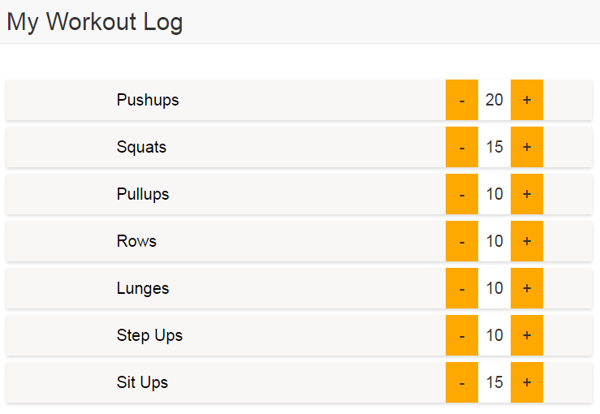

1. Open the **app.js** file and create a new module named ***ExerciseApp***.
2. Open your **index.html** and attach the module to the <body> element.
3. Open the **MainController.js** file. Take note of the **$scope.exercises** property that contains an array of several objects.
4. Attach the controller to the <div> element with the class “main”.
5. Uncomment the code and loop through the exercises array to display the exercise name and count.
6. In the controller, add another property called **$scope.increase**. Set it equal to a function that takes the index of the exercise that was clicked and adds one to that exercise’s count property.
7. Back in the **index.html** file, find the <span> element with the class “increase”. Add the ng-click directive to tell Angular to run the increase() function when the span is clicked. Use $index to pass the index of the item that was clicked.
8. In the controller, add another property called **$scope.decrease**. Set it equal to a function that will take the index of an exercise that was clicked, and subtract one from that exercise’s count property. Use ng-click to call the function when the <span> element with the class “decrease” is clicked.